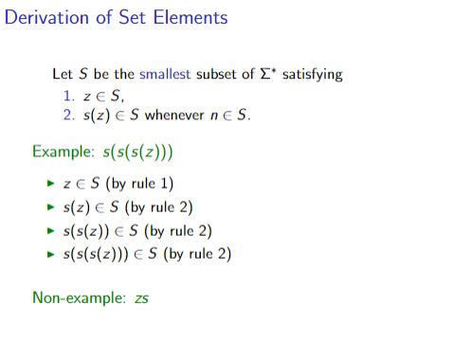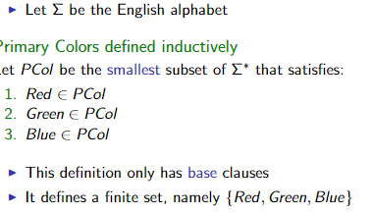 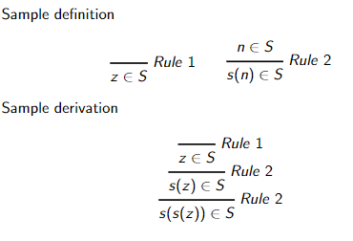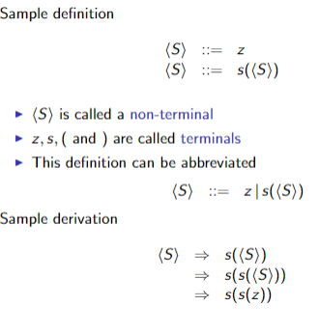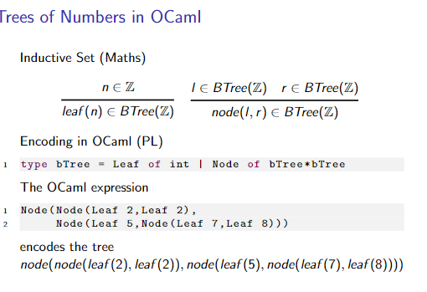

let rec tree -flip = function

2

| Leaf n -> Leaf n

3

| Node(l,r) -> Node(tree_flip r,tree_flip l)

Lambda calculus

Bound: x is bound in an expression

if it refers to a formal parameter introduced in E

Free: x is free in E if it is not declared in E

